MANAGER NOMINATIONS FOR 2022
Brief Background

Lorraine Eastwell
Board Member since 2021, Growth Group Coach for a number of years
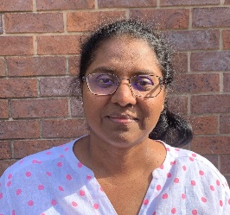
Divya Judge
Board Member since 2020, Involved with Hospitality Ministry, Lecturer

Rob Storrs
Board Member since 2021, Past Growth Group Leader, Engineer,

Emma Jane (EJ) McNicol
Corporate Solicitor, Co Leader Christianity Explored course, Welcomer, Volunteer board member of a number of charities.
Ryan White
Surveyor, Past Growth Group Leader

Andrew Tobin
Solicitor, Growth Group Leader, Bible Reader
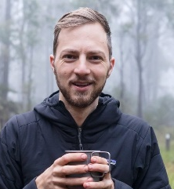
Matthew Nichol
Leads and Serves on Technical Production Team, Served in OM 2013/14, Previous leader with TeenStreet Australia, Electrical engineer

